**ICT 2105: Numerical Analysis**

**Secant Method**

The **secant method** is a root-finding procedure in numerical analysis that uses a series of roots of secant lines to better approximate a root of a function f. Let us learn more about the second method, its formula, advantages and limitations, and secant method solved example with detailed explanations in this article.

The tangent line to the curve of y = f(x) with the point of tangency (x0, f(x0) was used in Newton’s approach. The graph of the tangent line about x = α is essentially the same as the graph of y = f(x) when x0 ≈ α. The root of the tangent line was used to approximate α.

Let’s pretend we have two root estimations of root α, say, x0 and x1. Then, we have a linear function

q(x) = a0 + a1x

using q(x0) = f (x0), q(x1) = f (x1).

This line is also known as a secant line. Its formula is as follows:



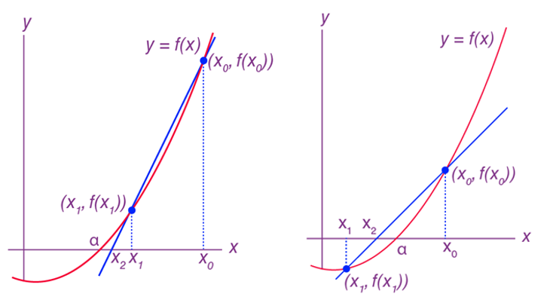

The linear equation q(x) = 0 is now solved, with the root denoted by x2. This results in



Let the above form be equation (1)

The procedure can now be repeated. Employ x1 and x2 to create a new secant line, and then use the root of that line to approximate α;…

**Secant Method Steps**

The secant method procedures are given below using equation (1).

**Step 1: Initialization**

x0 and x1 of α are taken as initial guesses.

**Step 2: Iteration**

In the case of n = 1, 2, 3, …,



until a specific criterion for termination has been met (i.e., The desired accuracy of the answer or the maximum number of iterations has been attained).

**Example-1**

Compute two iterations for the function f(x) = x3 – 5x + 1 = 0 using the secant method, in which the real roots of the equation f(x) lies in the interval (0, 1).

**Solution:**

Using the given data, we have,

x0 = 0, x1 = 1, and

f(x0) = 1, f(x1) = -3

Using the secant method formula, we can write

x2 = x1 – [(x0 – x1) / (f(x0) – f(x1))]f(x1)

Now, substitute the known values in the formula,

= 1 – [(0 – 1) / ((1-(-3))](-3)

= 0.25.

Therefore, f(x2) = – 0.234375

Performing the second approximation, ,

x3 = x2 – [( x1 – x2) / (f(x1) – f(x2))]f(x2)

=(- 0.234375) – [(1 – 0.25)/(-3 – (- 0.234375))](- 0.234375)

= 0.186441

Hence, f(x3) = 0.074276

**Example-2**



**Solution:**

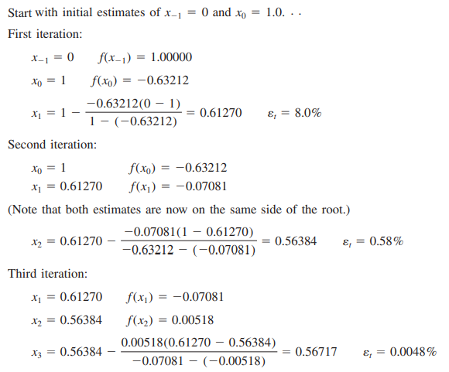

**Example-3**

Find a root of an equation $\int{\left(x\right)= x^{3}-x-1}$ using Secant method.

